#
# 20190402
# https://sd.tcsbank.ru/0/NUI/ViewModule.aspx#CardModuleV2/CasePage/edit/7b5f7ed8-1de6-4073-8bb2-9b4fc95d2212
#
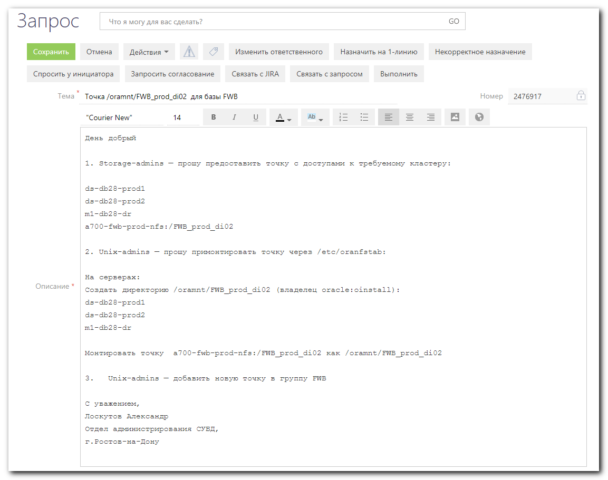

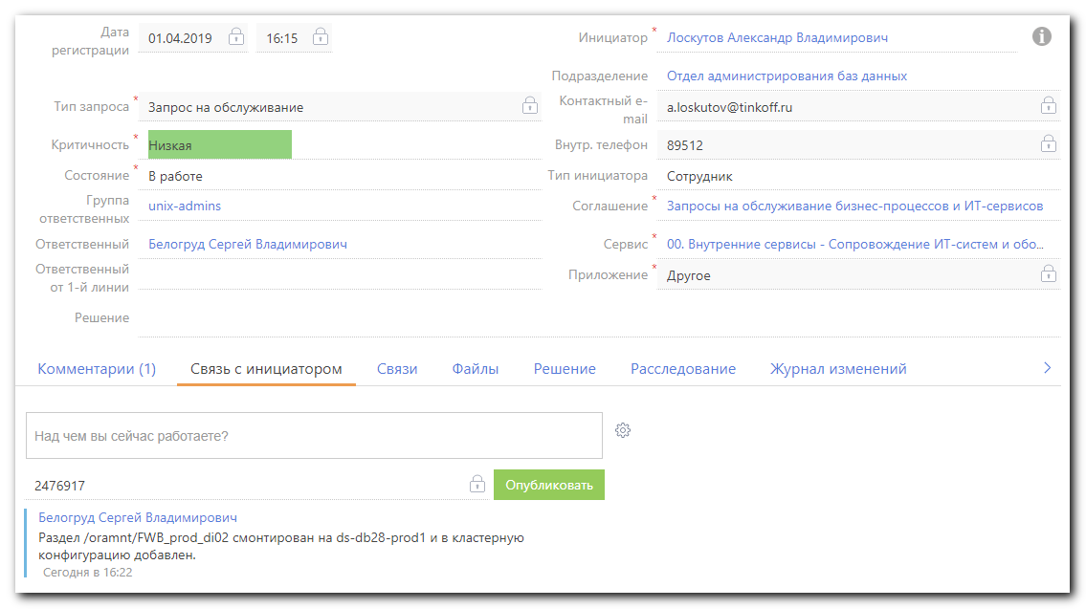
#
# SD#2476917
#

День добрый
1. Storage-admins — прошу предоставить точку с доступами к требуемому кластеру:
ds-db28-prod1
ds-db28-prod2
m1-db28-dr
a700-fwb-prod-nfs:/FWB_prod_di02

2. Unix-admins — прошу примонтировать точку через /etc/oranfstab:
На серверах:
Создать директорию /oramnt/FWB_prod_di02 (владелец oracle:oinstall):
ds-db28-prod1
ds-db28-prod2
m1-db28-dr

Монтировать точку a700-fwb-prod-nfs:/FWB_prod_di02 как /oramnt/FWB_prod_di02

3. Unix-admins — добавить новую точку в группу FWB

С уважением,
Лоскутов Александр
Отдел администрирования СУБД,
г.Ростов-на-Дону

https://gitlab.tcsbank.ru/jet/ansible/tree/master/group_vars
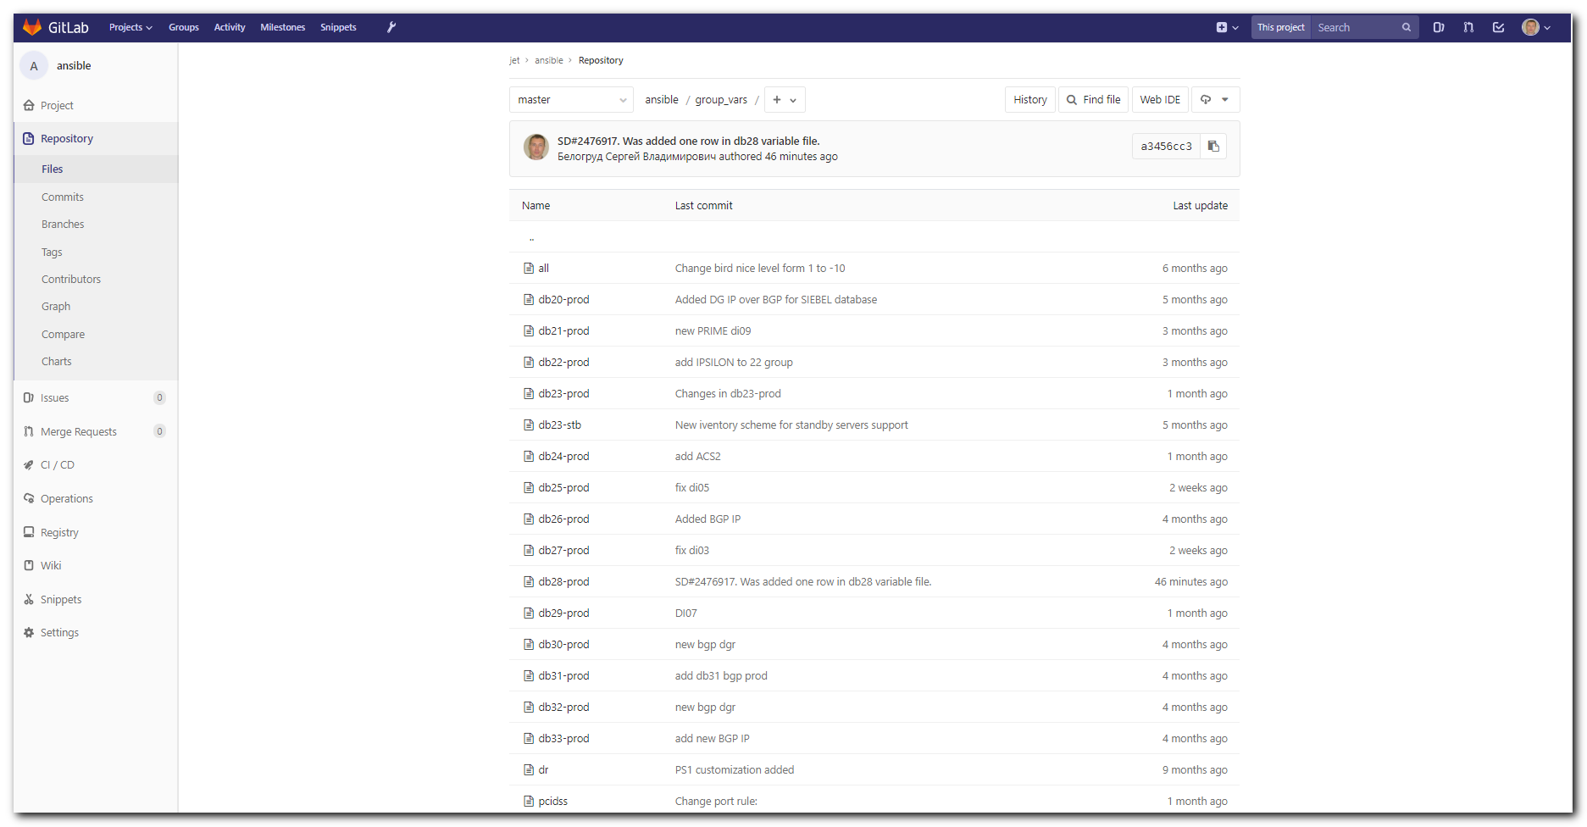

https://gitlab.tcsbank.ru/jet/ansible/blob/master/group_vars/db28-prod
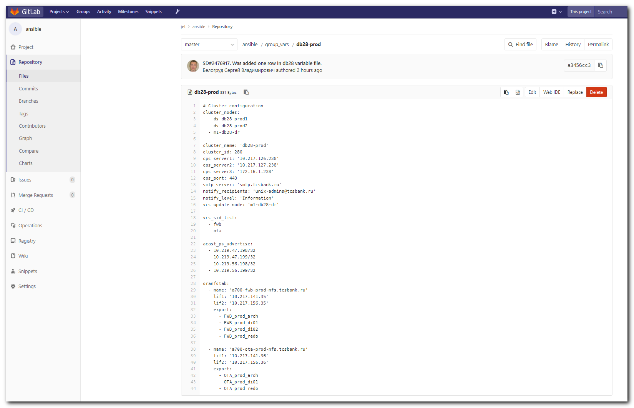

#
# It’s better to make changes on that place, where I can use ansible, than in MobaXterm. But in this example I’ve used MobaXterm environment.
#
[s.belogrud@TCS4357]# git clone git@vm-gitlab01.tcsbank.ru:jet/ansible.git
Cloning into 'ansible'...
remote: Counting objects: 3834, done.
remote: Compressing objects: 100% (11/11), done.
remote: Total 3834 (delta 10), reused 18 (delta 9)
Receiving objects: 100% (3834/3834), 20.54 MiB | 13.50 MiB/s, done.
Resolving deltas: 100% (2390/2390), done.
Checking connectivity... done.
Checking out files: 100% (339/339), done.
[s.belogrud@TCS4357]#

[s.belogrud@TCS4357]# git checkout -b 20190402_SD2476917
Switched to a new branch '20190402_SD2476917'
[s.belogrud@TCS4357]#

# Was added one line into the file.
[s.belogrud@TCS4357]# vim group_vars/db28-prod
...
oranfstab:
- name: 'a700-fwb-prod-nfs.tcsbank.ru'
lif1: '10.217.141.35'
lif2: '10.217.156.35'
export:
- FWB_prod_arch
- FWB_prod_di01
- FWB_prod_di02
- FWB_prod_redo
...

[s.belogrud@TCS4357]# git status
On branch 20190402_SD2476917
Changes not staged for commit:
(use "git add <file>..." to update what will be committed)
(use "git checkout -- <file>..." to discard changes in working directory)

modified: group_vars/db28-prod

no changes added to commit (use "git add" and/or "git commit -a")
[s.belogrud@TCS4357]#

[s.belogrud@TCS4357]# git commit --author='Sergey Belogrud <s.belogrud@tinkoff.ru>' -m "SD#2476917. Was added one row in db28 variable file." group_vars/db28-prod
[20190402_SD2476917 a3456cc] SD#2476917. Was added one row in db28 variable file.
Author: Sergey Belogrud <s.belogrud@tinkoff.ru>
1 file changed, 1 insertion(+)
[s.belogrud@TCS4357]# git push origin 20190402_SD2476917
Counting objects: 4, done.
Delta compression using up to 8 threads.
Compressing objects: 100% (4/4), done.
Writing objects: 100% (4/4), 415 bytes | 0 bytes/s, done.
Total 4 (delta 3), reused 0 (delta 0)
remote:
remote: To create a merge request for 20190402_SD2476917, visit:
remote: https://vm-gitlab01.tcsbank.ru/jet/ansible/merge_requests/new?merge_request%5Bsource_branch%5D=20190402_SD2476917
remote:
To git@vm-gitlab01.tcsbank.ru:jet/ansible.git
* [new branch] 20190402_SD2476917 -> 20190402_SD2476917
[s.belogrud@TCS4357]#

# The link opens in a browser.
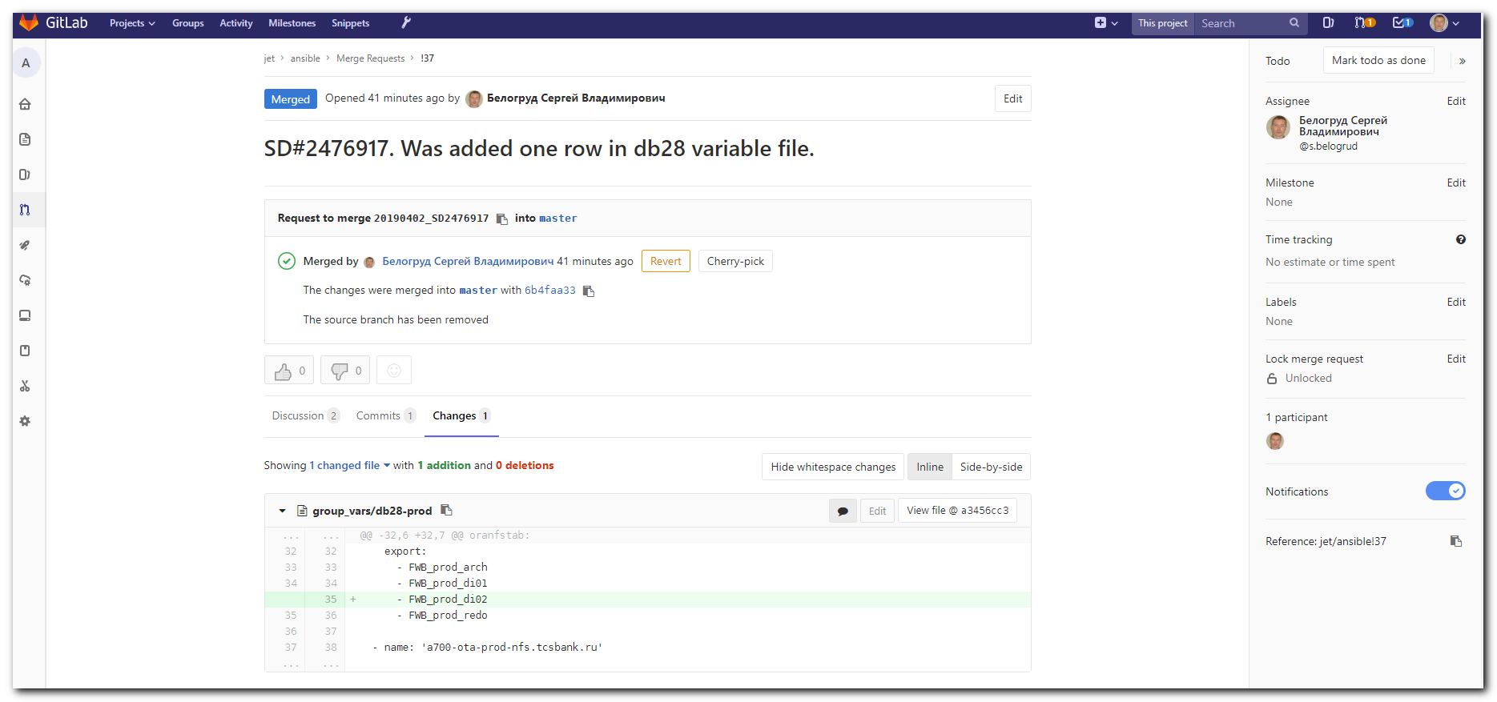
# I’ve assigned it to me and merged it.

[s.belogrud@TCS4357]# git checkout master
Switched to branch 'master'
Your branch is up-to-date with 'origin/master'.
[s.belogrud@TCS4357]# git branch
20190402_SD2476917
* master
[s.belogrud@TCS4357]# git branch -D 20190402_SD2476917
Deleted branch 20190402_SD2476917 (was a3456cc).
[s.belogrud@TCS4357]# git branch
* master
[s.belogrud@TCS4357]#

# Create mount point (directories) on all three servers.
# On server ds-db28-prod1 and
# on server ds-db28-prod2 and
# on server m1-db28-dr
#
mkdir /oramnt/FWB_prod_di02
chown oracle:oinstall /oramnt/FWB_prod_di02
chmod 755 /oramnt/FWB_prod_di02
ls -Alhd /oramnt/FWB_prod_di02

#
# It show, on what server database FWB is online.
#
[12:13:01 root@ds-db28-prod1 ~]# findmnt -t nfs -o SOURCE,TARGET | grep -ie "FWB_prod_di01"
a700-fwb-prod-nfs:/FWB_prod_di01 /oramnt/FWB_prod_di01
[12:13:16 root@ds-db28-prod1 ~]#

#
# Here I’ve collected commands, that I will use to create new resources.
# Only needs to replace …-di01 to …-di02. But here I need only nfs mount options.
# These options I will use to manually mount nfs resource.
#
[15:52:20 root@m1-db28-dr ~]# grep -ie "FWB.*di01" /etc/VRTSvcs/conf/config/main.cmd
...
hares -modify mnt-FWB-di01 MountPoint "/oramnt/FWB_prod_di01"
hares -modify mnt-FWB-di01 BlockDevice "a700-fwb-prod-nfs:/FWB_prod_di01"
...
hares -modify mnt-FWB-di01 MountOpt "rw,bg,vers=3,tcp,timeo=600,rsize=65536,wsize=65536,hard,nolock"
...
[15:52:25 root@m1-db28-dr ~]#

[15:53:04 root@ds-db28-prod1 ~]# mount -t nfs -o rw,bg,vers=3,tcp,timeo=600,rsize=65536,wsize=65536,hard,nolock a700-fwb-prod-nfs:/FWB_prod_di02 /oramnt/FWB_prod_di02
[15:54:15 root@ds-db28-prod1 ~]# ls -Alhd /oramnt/FWB_prod_di02
drwxr-xr-x 2 root root 4.0K Apr 2 09:12 /oramnt/FWB_prod_di02
# After successful mount need to correct owners of directory.
[15:54:31 root@ds-db28-prod1 ~]# chown oracle:oinstall /oramnt/FWB_prod_di02
[15:54:53 root@ds-db28-prod1 ~]# ls -Alhd /oramnt/FWB_prod_di02
drwxr-xr-x 2 oracle oinstall 4.0K Apr 2 09:12 /oramnt/FWB_prod_di02
[15:54:54 root@ds-db28-prod1 ~]#

#
# Here it’s need to apply our previous changes in ansible jet repository to target servers.
# I have ansible on my centos virtualbox host. I use it for my goals.
[support@centos ~]$ cd work
[support@centos work]$ mkdir ansible.jet
[support@centos work]$ cd ansible.jet
[support@centos ansible.jet]$ git clone git@vm-gitlab01.tcsbank.ru:jet/ansible.git
Cloning into 'ansible'...
remote: Counting objects: 3839, done.
remote: Compressing objects: 100% (16/16), done.
remote: Total 3839 (delta 14), reused 16 (delta 9)
Receiving objects: 100% (3839/3839), 20.54 MiB | 0 bytes/s, done.
Resolving deltas: 100% (2394/2394), done.
[support@centos ansible.jet]$

# To see available tags.
[support@centos ansible]$ ansible-playbook -i production oracle.yml --list-tags

playbook: oracle.yml

play #1 (oracle): oracle TAGS: []
TASK TAGS: [backup_user, dirs, logrotate_oraconf, logrotate_oracron, logrotate_orascript, ora_user, oracron, orafake, oramnt, oranfstab, oratab, pkg, rsyslog, tuning, vmtuning]
[support@centos ansible]$

#
# Let’s test our changes.
[support@centos ansible]$ ansible-playbook -i production oracle.yml --tags oranfstab --limit db28-prod --check --diff --extra-vars "ansible_user=bsv ansible_password=$(pass common/linux) ansible_sudo_pass=$(pass common/linux) ansible_ssh_common_args='-oStrictHostKeyChecking=no -oPubkeyAuthentication=no'"

PLAY [oracle] ****************************************************************************************************************************************************************************************

TASK [Gathering Facts] *******************************************************************************************************************************************************************************
ok: [ds-db28-prod2]
ok: [m1-db28-dr]
ok: [ds-db28-prod1]

TASK [oracle : Create /etc/oranfstab] ****************************************************************************************************************************************************************
--- before: /etc/oranfstab
+++ after: /home/support/.ansible/tmp/ansible-local-14497tR45CB/tmphFkR2x/oranfstab.j2
@@ -18,6 +18,7 @@
dontroute
export:/FWB_prod_arch mount:/oramnt/FWB_prod_arch
export:/FWB_prod_di01 mount:/oramnt/FWB_prod_di01
+export:/FWB_prod_di02 mount:/oramnt/FWB_prod_di02
export:/FWB_prod_redo mount:/oramnt/FWB_prod_redo

###############################################

changed: [m1-db28-dr]
--- before: /etc/oranfstab
+++ after: /home/support/.ansible/tmp/ansible-local-14497tR45CB/tmpdI7U8Z/oranfstab.j2
@@ -18,6 +18,7 @@
dontroute
export:/FWB_prod_arch mount:/oramnt/FWB_prod_arch
export:/FWB_prod_di01 mount:/oramnt/FWB_prod_di01
+export:/FWB_prod_di02 mount:/oramnt/FWB_prod_di02
export:/FWB_prod_redo mount:/oramnt/FWB_prod_redo

###############################################

changed: [ds-db28-prod1]
--- before: /etc/oranfstab
+++ after: /home/support/.ansible/tmp/ansible-local-14497tR45CB/tmp05_yDP/oranfstab.j2
@@ -18,6 +18,7 @@
dontroute
export:/FWB_prod_arch mount:/oramnt/FWB_prod_arch
export:/FWB_prod_di01 mount:/oramnt/FWB_prod_di01
+export:/FWB_prod_di02 mount:/oramnt/FWB_prod_di02
export:/FWB_prod_redo mount:/oramnt/FWB_prod_redo

###############################################

changed: [ds-db28-prod2]

PLAY RECAP *******************************************************************************************************************************************************************************************
ds-db28-prod1 : ok=2 changed=1 unreachable=0 failed=0
ds-db28-prod2 : ok=2 changed=1 unreachable=0 failed=0
m1-db28-dr : ok=2 changed=1 unreachable=0 failed=0

[support@centos ansible]$

[support@centos ansible]$ ansible-playbook -i production oracle.yml --tags oranfstab --limit db28-prod --extra-vars "ansible_user=bsv ansible_password=$(pass common/linux) ansible_sudo_pass=$(pass common/linux) ansible_ssh_common_args='-oStrictHostKeyChecking=no -oPubkeyAuthentication=no'"

PLAY [oracle] ****************************************************************************************************************************************************************************************

TASK [Gathering Facts] *******************************************************************************************************************************************************************************
ok: [m1-db28-dr]
ok: [ds-db28-prod2]
ok: [ds-db28-prod1]

TASK [oracle : Create /etc/oranfstab] ****************************************************************************************************************************************************************
changed: [ds-db28-prod2]
changed: [m1-db28-dr]
changed: [ds-db28-prod1]

PLAY RECAP *******************************************************************************************************************************************************************************************
ds-db28-prod1 : ok=2 changed=1 unreachable=0 failed=0
ds-db28-prod2 : ok=2 changed=1 unreachable=0 failed=0
m1-db28-dr : ok=2 changed=1 unreachable=0 failed=0

[support@centos ansible]$

...........................................................................

#
# Here I’ve collected commands, that I will use to create new resources.
# Only need to replace …-di01 to …-di02.
#
[15:52:20 root@m1-db28-dr ~]# grep -ie "FWB.*di01" /etc/VRTSvcs/conf/config/main.cmd
hares -add mnt-FWB-di01 Mount OraFWB
hares -modify mnt-FWB-di01 MountPoint "/oramnt/FWB_prod_di01"
hares -modify mnt-FWB-di01 BlockDevice "a700-fwb-prod-nfs:/FWB_prod_di01"
hares -modify mnt-FWB-di01 FSType nfs
hares -modify mnt-FWB-di01 MountOpt "rw,bg,vers=3,tcp,timeo=600,rsize=65536,wsize=65536,hard,nolock"
hares -modify mnt-FWB-di01 FsckOpt "%-n"
hares -modify mnt-FWB-di01 CreateMntPt 1
hares -modify mnt-FWB-di01 SnapUmount 0
hares -modify mnt-FWB-di01 CkptUmount 1
hares -modify mnt-FWB-di01 RecursiveMnt 0
hares -modify mnt-FWB-di01 VxFSMountLock 1
hares -modify mnt-FWB-di01 CacheRestoreAccess 0
hares -modify mnt-FWB-di01 Enabled 1
hares -link GxClusterPlugin_OraFWB mnt-FWB-di01
hares -link mnt-FWB-di01 proxy-FWB-kNFS
hares -link ora-FWB mnt-FWB-di01
[15:52:25 root@m1-db28-dr ~]#

#
# Here I’ve made changes in vim in temporary document.
#
hares -add mnt-FWB-di02 Mount OraFWB
hares -modify mnt-FWB-di02 MountPoint "/oramnt/FWB_prod_di02"
hares -modify mnt-FWB-di02 BlockDevice "a700-fwb-prod-nfs:/FWB_prod_di02"
hares -modify mnt-FWB-di02 FSType nfs
hares -modify mnt-FWB-di02 MountOpt "rw,bg,vers=3,tcp,timeo=600,rsize=65536,wsize=65536,hard,nolock"
hares -modify mnt-FWB-di02 FsckOpt "%-n"
hares -modify mnt-FWB-di02 CreateMntPt 1
hares -modify mnt-FWB-di02 SnapUmount 0
hares -modify mnt-FWB-di02 CkptUmount 1
hares -modify mnt-FWB-di02 RecursiveMnt 0
hares -modify mnt-FWB-di02 VxFSMountLock 1
hares -modify mnt-FWB-di02 CacheRestoreAccess 0

# This line was added manually.
hares -modify mnt-FWB-di02 Critical 0

hares -modify mnt-FWB-di02 Enabled 1
hares -link GxClusterPlugin_OraFWB mnt-FWB-di02

# Take this commnad from that cluster, where we will apply these commnad. It's important to be sure that "kNFS" is used on this cluster. On other resources on other clusters we could meet "vNFS".
hares -link mnt-FWB-di02 proxy-FWB-kNFS
hares -link ora-FWB mnt-FWB-di02

...........................................................................
#
# Here I’ve created a script, that contain our commands.
#
[16:06:23 root@m1-db28-dr ~]# cat > /tmp/20190402.sh
hares -add mnt-FWB-di02 Mount OraFWB
hares -modify mnt-FWB-di02 MountPoint "/oramnt/FWB_prod_di02"
hares -modify mnt-FWB-di02 BlockDevice "a700-fwb-prod-nfs:/FWB_prod_di02"
hares -modify mnt-FWB-di02 FSType nfs
hares -modify mnt-FWB-di02 MountOpt "rw,bg,vers=3,tcp,timeo=600,rsize=65536,wsize=65536,hard,nolock"
hares -modify mnt-FWB-di02 FsckOpt "%-n"
hares -modify mnt-FWB-di02 CreateMntPt 1
hares -modify mnt-FWB-di02 SnapUmount 0
hares -modify mnt-FWB-di02 CkptUmount 1
hares -modify mnt-FWB-di02 RecursiveMnt 0
hares -modify mnt-FWB-di02 VxFSMountLock 1
hares -modify mnt-FWB-di02 CacheRestoreAccess 0

# Was added manually.
hares -modify mnt-FWB-di02 Critical 0

hares -modify mnt-FWB-di02 Enabled 1
hares -link GxClusterPlugin_OraFWB mnt-FWB-di02

# Take this commnad from that cluster, where we will apply these commnad. It's important to be sure that "kNFS" is used on this cluster. On other resources on other clusters we could meet "vNFS".
hares -link mnt-FWB-di02 proxy-FWB-kNFS
hares -link ora-FWB mnt-FWB-di02

[16:06:38 root@m1-db28-dr ~]# vim /tmp/20190402.sh

#
# Were commented latest two lines with link command.
# It’s because these commands are sencetive and better to run it separately and after all other commands will apply successfully.
[16:10:31 root@m1-db28-dr ~]# cat /tmp/20190402.sh
hares -add mnt-FWB-di02 Mount OraFWB
hares -modify mnt-FWB-di02 MountPoint "/oramnt/FWB_prod_di02"
hares -modify mnt-FWB-di02 BlockDevice "a700-fwb-prod-nfs:/FWB_prod_di02"
hares -modify mnt-FWB-di02 FSType nfs
hares -modify mnt-FWB-di02 MountOpt "rw,bg,vers=3,tcp,timeo=600,rsize=65536,wsize=65536,hard,nolock"
hares -modify mnt-FWB-di02 FsckOpt "%-n"
hares -modify mnt-FWB-di02 CreateMntPt 1
hares -modify mnt-FWB-di02 SnapUmount 0
hares -modify mnt-FWB-di02 CkptUmount 1
hares -modify mnt-FWB-di02 RecursiveMnt 0
hares -modify mnt-FWB-di02 VxFSMountLock 1
hares -modify mnt-FWB-di02 CacheRestoreAccess 0

# Was added manually.
hares -modify mnt-FWB-di02 Critical 0

hares -modify mnt-FWB-di02 Enabled 1
hares -link GxClusterPlugin_OraFWB mnt-FWB-di02

# Take this commnad from that cluster, where we will apply these commnad. It's important to be sure that "kNFS" is used on this cluster. On other resources on other clusters we could meet "vNFS".

#
# Let's comment follow two lines.
# hares -link mnt-FWB-di02 proxy-FWB-kNFS
# hares -link ora-FWB mnt-FWB-di02
[16:10:40 root@m1-db28-dr ~]#

#
# Recommended to run Veritas Cluster GUI.
# It’s better to note links and it corrections via picture.
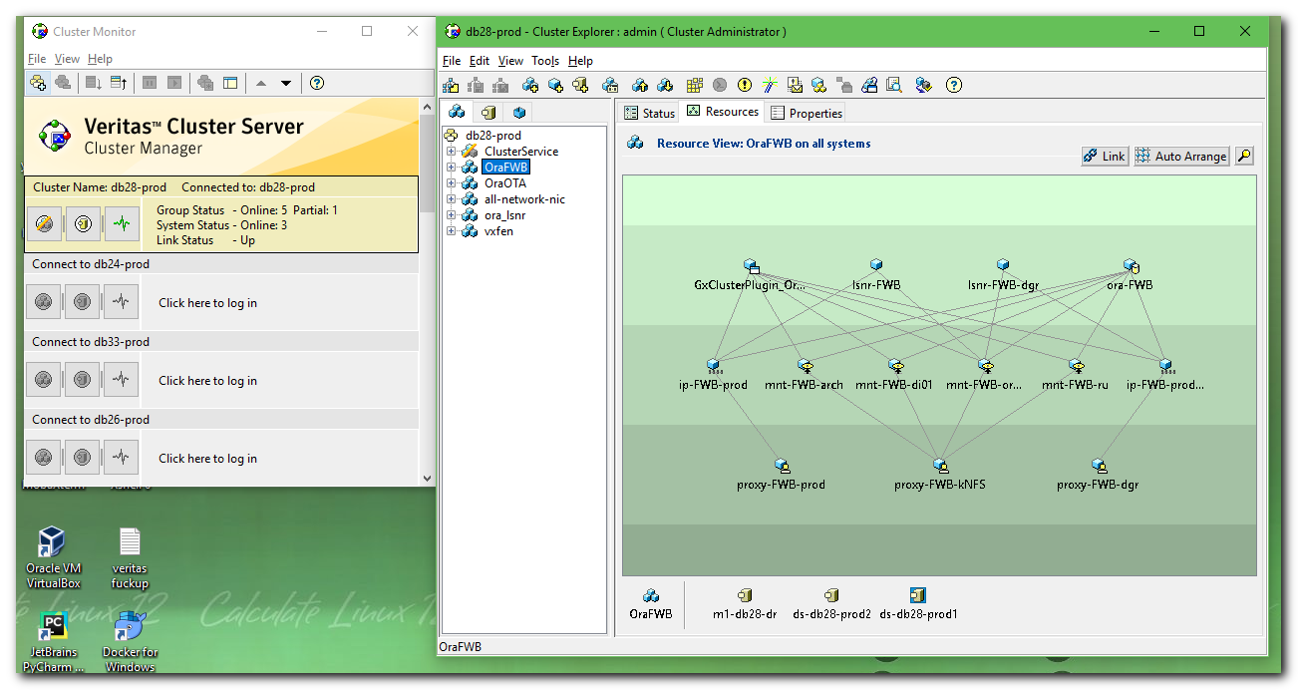

# This command makes configuratioin available for write changes.
[16:10:40 root@m1-db28-dr ~]# haconf -makerw
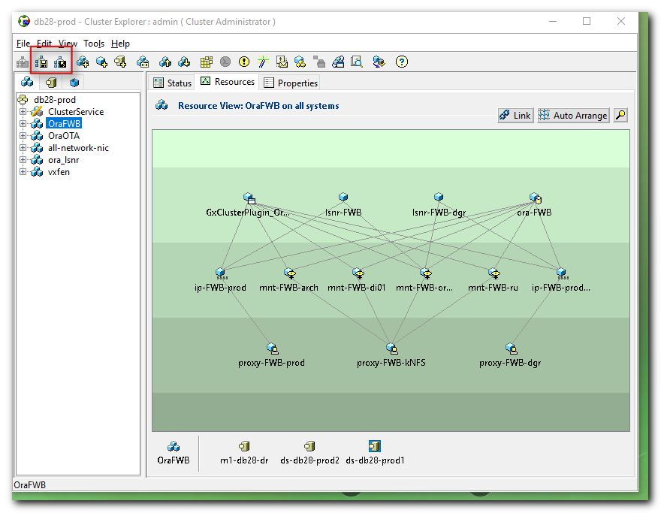
# Execute our commands in the script.
[16:10:57 root@m1-db28-dr ~]# . /tmp/20190402.sh
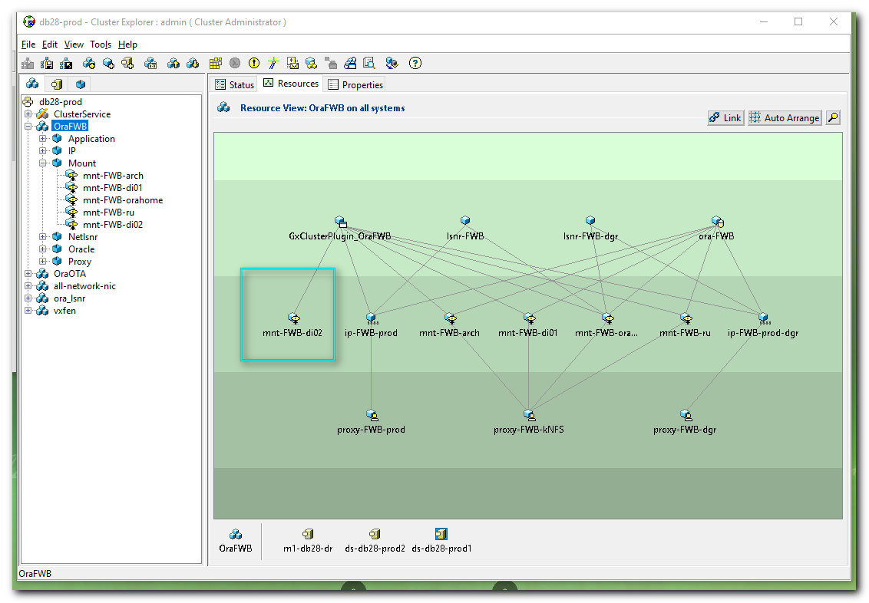

# And separately run two commands, that link resources.
[16:12:48 root@m1-db28-dr ~]# hares -link mnt-FWB-di02 proxy-FWB-kNFS
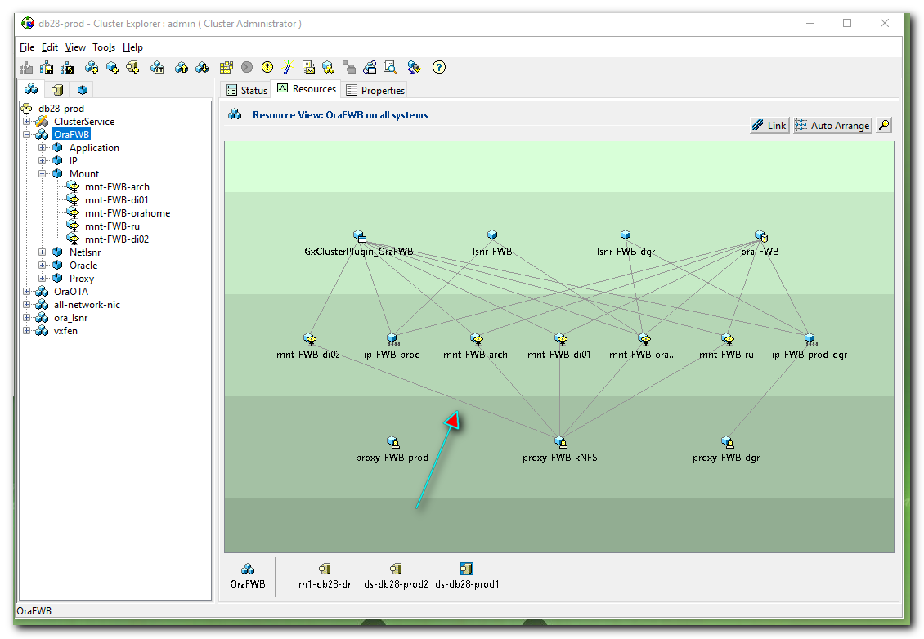

[16:13:46 root@m1-db28-dr ~]# hares -link ora-FWB mnt-FWB-di02
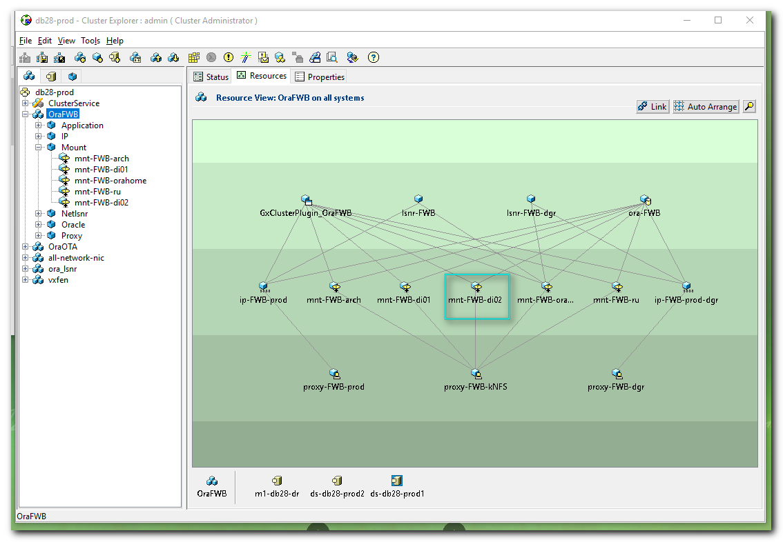

[16:17:46 root@m1-db28-dr ~]# hares -modify mnt-FWB-di02 Critical 1
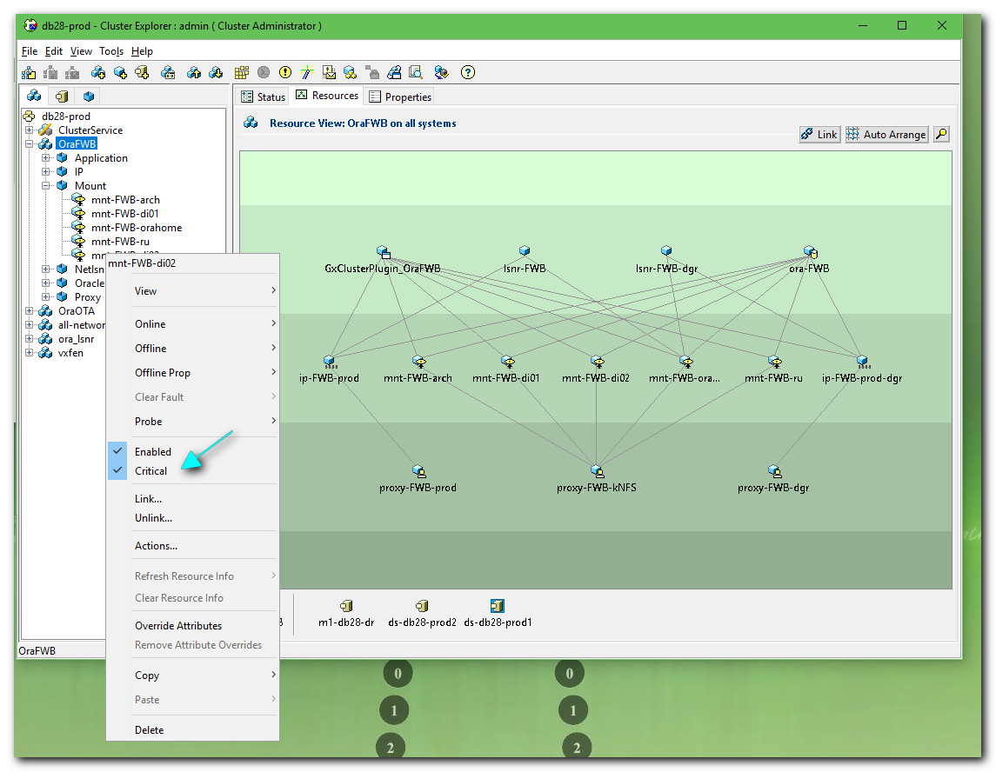

# Return configuration to Read Only state after our changes was made successfully.
[16:17:55 root@m1-db28-dr ~]# haconf -dump -makero
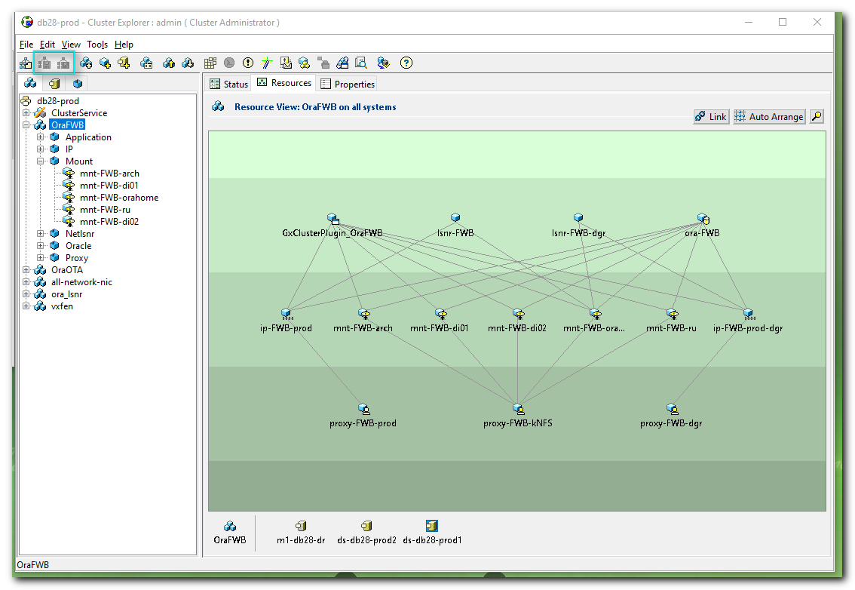

...........................................................................
#
# This conclutions was written by me in comment for this Service desk task.
#
Раздел /oramnt/FWB_prod_di02 смонтирован на ds-db28-prod1 и в кластерную конфигурацию добавлен.

...........................................................................

#
# Ask for someone of colleagues to test added resource on cluster.

# That’s it.
# The end.

#
# Below is not completed steps of commands. It was the first attempt.
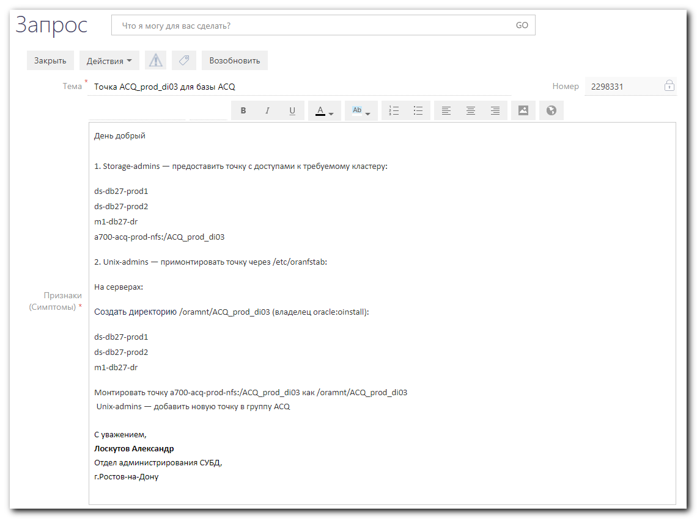
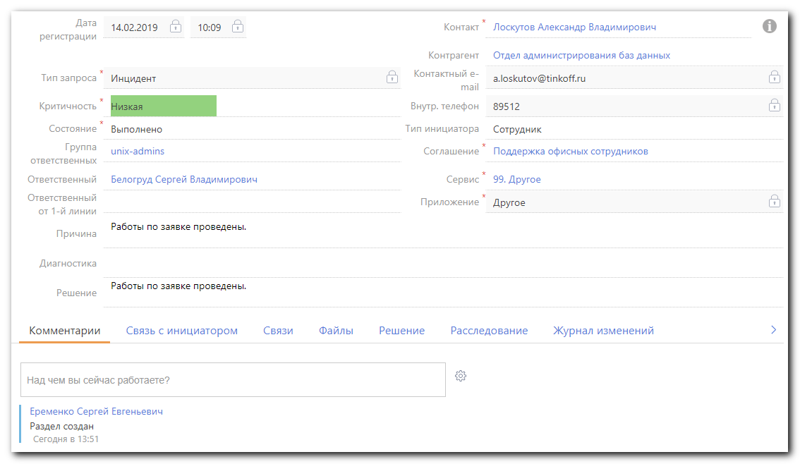

#
# Aleksandrov explained - how do do this taks right.
#
# Here is only what I remembered. That’s not all, what had been done.

# We need use same commands for new resource as it were for previous one.
# For example - for ...di02 resource.
[17:57:26 root@ds-db27-prod1 ~]# grep -ie "mnt-acq-di02" /etc/VRTSvcs/conf/config/main.cmd
hares -add mnt-ACQ-di02 Mount OraACQ
hares -modify mnt-ACQ-di02 MountPoint "/oramnt/ACQ_prod_di02"
hares -modify mnt-ACQ-di02 BlockDevice "a700-acq-prod-nfs:/ACQ_prod_di02"
hares -modify mnt-ACQ-di02 FSType nfs
hares -modify mnt-ACQ-di02 MountOpt "rw,bg,vers=3,tcp,timeo=600,rsize=65536,wsize=65536,hard,nolock"
hares -modify mnt-ACQ-di02 FsckOpt "%-n"
hares -modify mnt-ACQ-di02 CreateMntPt 1
hares -modify mnt-ACQ-di02 SnapUmount 0
hares -modify mnt-ACQ-di02 CkptUmount 1
hares -modify mnt-ACQ-di02 RecursiveMnt 0
hares -modify mnt-ACQ-di02 VxFSMountLock 1
hares -modify mnt-ACQ-di02 CacheRestoreAccess 0
hares -modify mnt-ACQ-di02 Enabled 1
hares -link GxClusterPlugin_OraACQ mnt-ACQ-di02
hares -link mnt-ACQ-di02 proxy-ACQ-kNFS
hares -link ora-ACQ mnt-ACQ-di02
[17:57:35 root@ds-db27-prod1 ~]#

#
# We will change “02” to “03”.
#
hares -add mnt-ACQ-di03 Mount OraACQ
hares -modify mnt-ACQ-di03 MountPoint "/oramnt/ACQ_prod_di03"
hares -modify mnt-ACQ-di03 BlockDevice "a700-acq-prod-nfs:/ACQ_prod_di03"
hares -modify mnt-ACQ-di03 FSType nfs
hares -modify mnt-ACQ-di03 MountOpt "rw,bg,vers=3,tcp,timeo=600,rsize=65536,wsize=65536,hard,nolock"
hares -modify mnt-ACQ-di03 FsckOpt "%-n"
hares -modify mnt-ACQ-di03 CreateMntPt 1
hares -modify mnt-ACQ-di03 SnapUmount 0
hares -modify mnt-ACQ-di03 CkptUmount 1
hares -modify mnt-ACQ-di03 RecursiveMnt 0
hares -modify mnt-ACQ-di03 VxFSMountLock 1
hares -modify mnt-ACQ-di03 CacheRestoreAccess 0
hares -modify mnt-ACQ-di03 Enabled 1
hares -link GxClusterPlugin_OraACQ mnt-ACQ-di03
hares -link mnt-ACQ-di03 proxy-ACQ-kNFS
hares -link ora-ACQ mnt-ACQ-di03

# Before we will start - it’s need to mount nfs-resource.
# Here we create directories.
[16:43:56 root@ds-db27-prod1 ~]# mkdir /oramnt/ACQ_prod_di03
[16:44:34 root@ds-db27-prod1 ~]# chown oracle:oinstall /oramnt/ACQ_prod_di03
[16:45:13 root@ds-db27-prod1 ~]# chmod 755 /oramnt/ACQ_prod_di03
[16:45:31 root@ds-db27-prod1 ~]# ls -Alhd /oramnt/ACQ_prod_di03
drwxr-xr-x 2 oracle oinstall 4.0K Feb 14 16:44 /oramnt/ACQ_prod_di03
[16:45:33 root@ds-db27-prod1 ~]#

[16:44:02 root@ds-db27-prod2 ~]# mkdir /oramnt/ACQ_prod_di03
[16:44:41 root@ds-db27-prod2 ~]# chown oracle:oinstall /oramnt/ACQ_prod_di03
[16:45:02 root@ds-db27-prod2 ~]# chmod 755 /oramnt/ACQ_prod_di03
[16:45:42 root@ds-db27-prod2 ~]# ls -Alhd /oramnt/ACQ_prod_di03
drwxr-xr-x 2 oracle oinstall 4.0K Feb 14 16:44 /oramnt/ACQ_prod_di03
[16:45:51 root@ds-db27-prod2 ~]#

[16:47:45 root@m1-db27-dr ~]# mkdir /oramnt/ACQ_prod_di03
[16:47:54 root@m1-db27-dr ~]# chown oracle:oinstall /oramnt/ACQ_prod_di03
[16:48:00 root@m1-db27-dr ~]# chmod 755 /oramnt/ACQ_prod_di03
[16:48:08 root@m1-db27-dr ~]# ls -Alhd /oramnt/ACQ_prod_di03
drwxr-xr-x 2 oracle oinstall 4.0K Feb 14 16:47 /oramnt/ACQ_prod_di03
[16:48:14 root@m1-db27-dr ~]#

# I’s need to find server, where database ACQ is online.
# Mount options was taken from this command: “hares -modify mnt-ACQ-di02 MountOpt "rw,bg,vers=3,tcp,timeo=600,rsize=65536,wsize=65536,hard,nolock".
mount -t nfs -o rw,bg,vers=3,tcp,timeo=600,rsize=65536,wsize=65536,hard,nolock a700-acq-prod-nfs:/ACQ_prod_di03 /oramnt/ACQ_prod_di03

# And mount nfs-resource on that server.
# This is after nfs-resource successfuly mounted.
[18:13:55 root@ds-db27-prod1 ~]# findmnt -t nfs -o SOURCE,TARGET
SOURCE TARGET
a700-pri4acq-prod-nfs:/PRI4ACQ_prod_home /opt/oracle/product/PRI4ACQ
a700-onl4acq-prod-nfs:/ONL4ACQ_prod_home /opt/oracle/product/ONL4ACQ
a700-acq-prod-nfs:/ACQ_prod_home /opt/oracle/product/ACQ
a700-apsv-prod-nfs:/APSV_prod_home /opt/oracle/product/APSV
v6250-ds.tcsbank.ru:/vol/common/distr_oradb /mnt/distr_oradb
a700-atm-prod-nfs:/ATM_prod_redo /oramnt/ATM_prod_redo
a700-atm-prod-nfs:/ATM_prod_home/oh18 /oramnt/ATM_prod_oh18
a700-atm-prod-nfs:/ATM_prod_di01 /oramnt/ATM_prod_di01
a700-pri4acq-prod-nfs:/PRI4ACQ_prod_di02 /oramnt/PRI4ACQ_prod_di02
a700-pri4acq-prod-nfs:/PRI4ACQ_prod_di01 /oramnt/PRI4ACQ_prod_di01
v6250-m1.tcsbank.ru:/vol/primeshare/exchprod_db /mnt/oradata/exchprod/db
a700-pri4acq-prod-nfs:/PRI4ACQ_prod_redo /oramnt/PRI4ACQ_prod_redo
a700-buff-prod-nfs:/a700_prod_lsnr /oramnt/listener_prod
a700-pri4acq-prod-nfs:/PRI4ACQ_prod_arch /oramnt/PRI4ACQ_prod_arch
a700-onl4acq-prod-nfs:/ONL4ACQ_prod_arch /oramnt/ONL4ACQ_prod_arch
a700-onl4acq-prod-nfs:/ONL4ACQ_prod_di01 /oramnt/ONL4ACQ_prod_di01
a700-onl4acq-prod-nfs:/ONL4ACQ_prod_redo /oramnt/ONL4ACQ_prod_redo
a700-acq-prod-nfs:/ACQ_prod_arch /oramnt/ACQ_prod_arch
a700-acq-prod-nfs:/ACQ_prod_di01 /oramnt/ACQ_prod_di01
a700-acq-prod-nfs:/ACQ_prod_di02 /oramnt/ACQ_prod_di02
a700-acq-prod-nfs:/ACQ_prod_redo /oramnt/ACQ_prod_redo
a700-atm-prod-nfs:/ATM_prod_arch /oramnt/ATM_prod_arch
a700-apsv-prod-nfs:/APSV_prod_arch /oramnt/APSV_prod_arch
a700-apsv-prod-nfs:/APSV_prod_redo /oramnt/APSV_prod_redo
a700-apsv-prod-nfs:/APSV_prod_di01 /oramnt/APSV_prod_di01
a700-atm-prod-nfs:/ATM_prod_home/base /oramnt/ATM_prod_base
a700-acq-prod-nfs:/ACQ_prod_di03 /oramnt/ACQ_prod_di03
[18:14:15 root@ds-db27-prod1 ~]#

# Other parts of this instruction was lost from memory…
# Aleksandrov Aleksey promised to make an article on wiki.
...........................................................................

#
# It’s recommended, after all - make changes in /etc/oranfstab.
#

[16:45:33 root@ds-db27-prod1 ~]# vim /etc/oranfstab
...
export:/ACQ_prod_di03 mount:/oramnt/ACQ_prod_di03
...

[16:45:51 root@ds-db27-prod2 ~]# vim /etc/oranfstab
...
export:/ACQ_prod_di03 mount:/oramnt/ACQ_prod_di03
...

[16:48:14 root@m1-db27-dr ~]# vim /etc/oranfstab
...
export:/ACQ_prod_di03 mount:/oramnt/ACQ_prod_di03
...

...........................................................................

#
# And changes have to be inserted into Ansible repository, where was stored variables.

